* We can define what type of props we need and if its required or optional etc with prop-types. For this we need to install a package from npm named prop-types.

After we define our component, we have to go to the bottom and define the proptypes. For the complete list of types, check react documentation.

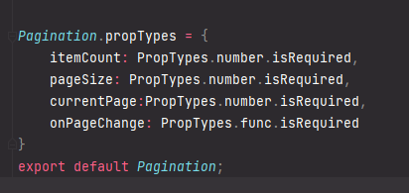

* We can define a default value for our props. Here is a snippet of an example.

